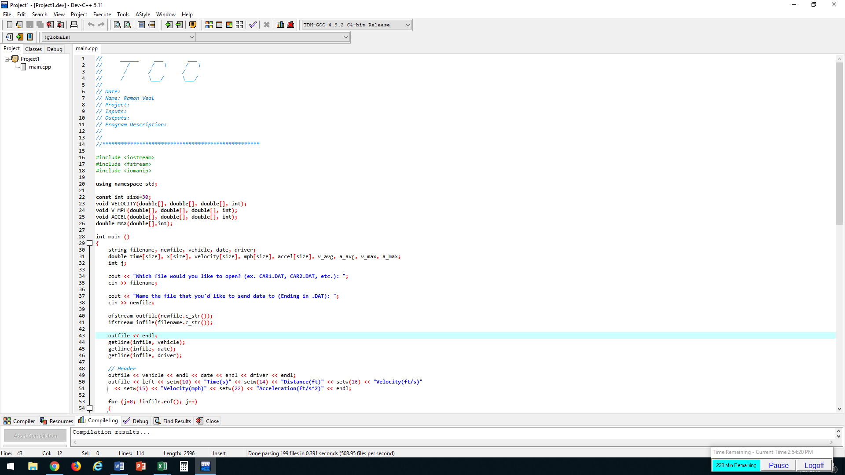

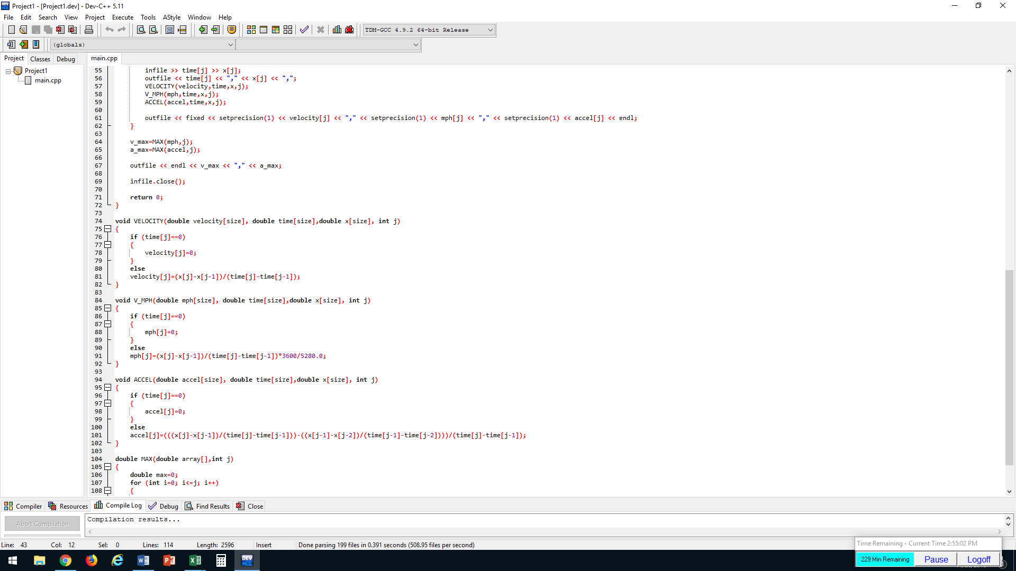

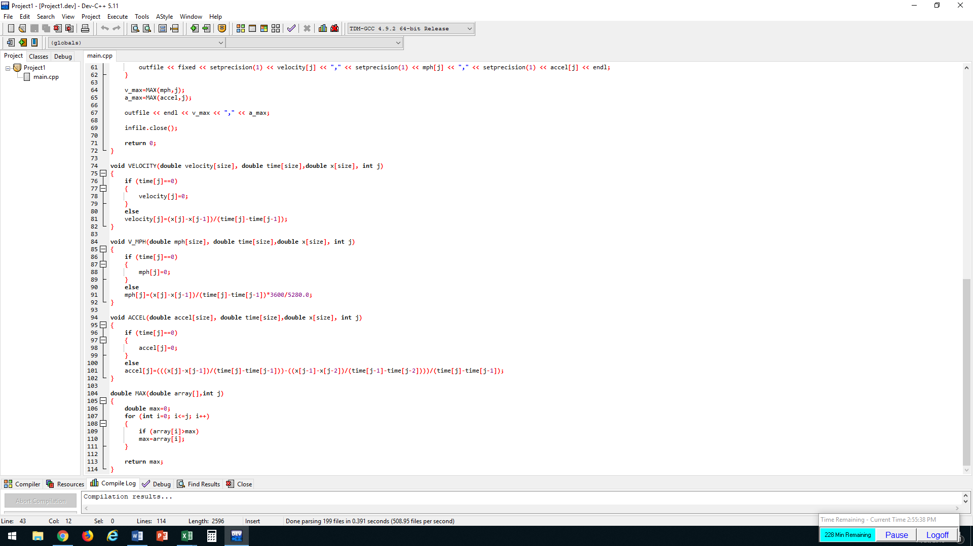

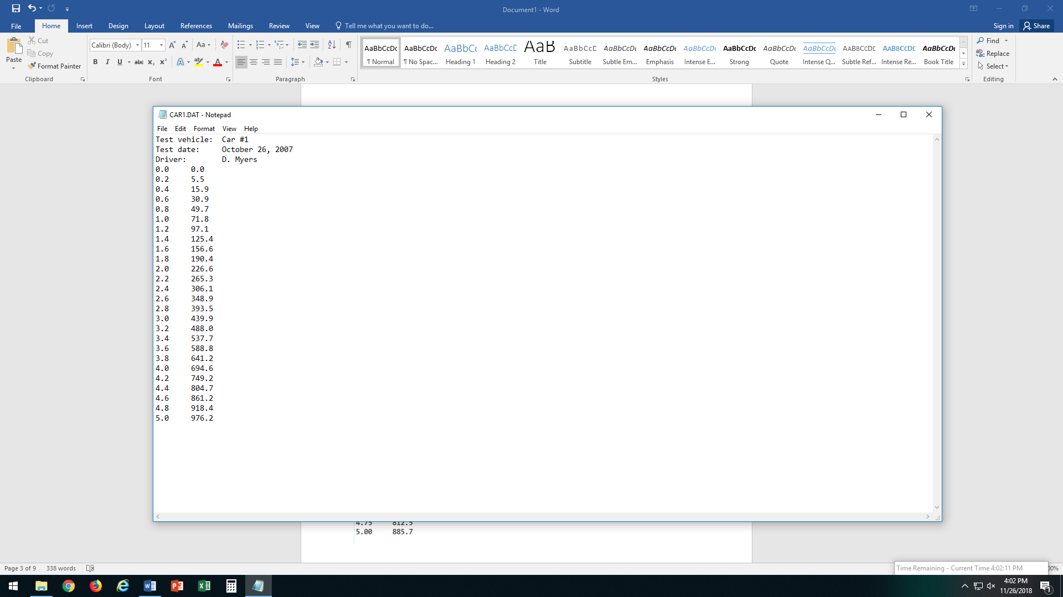 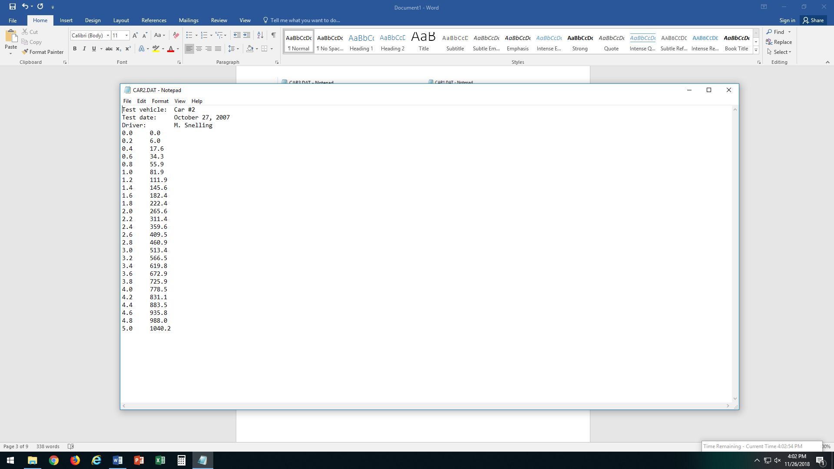

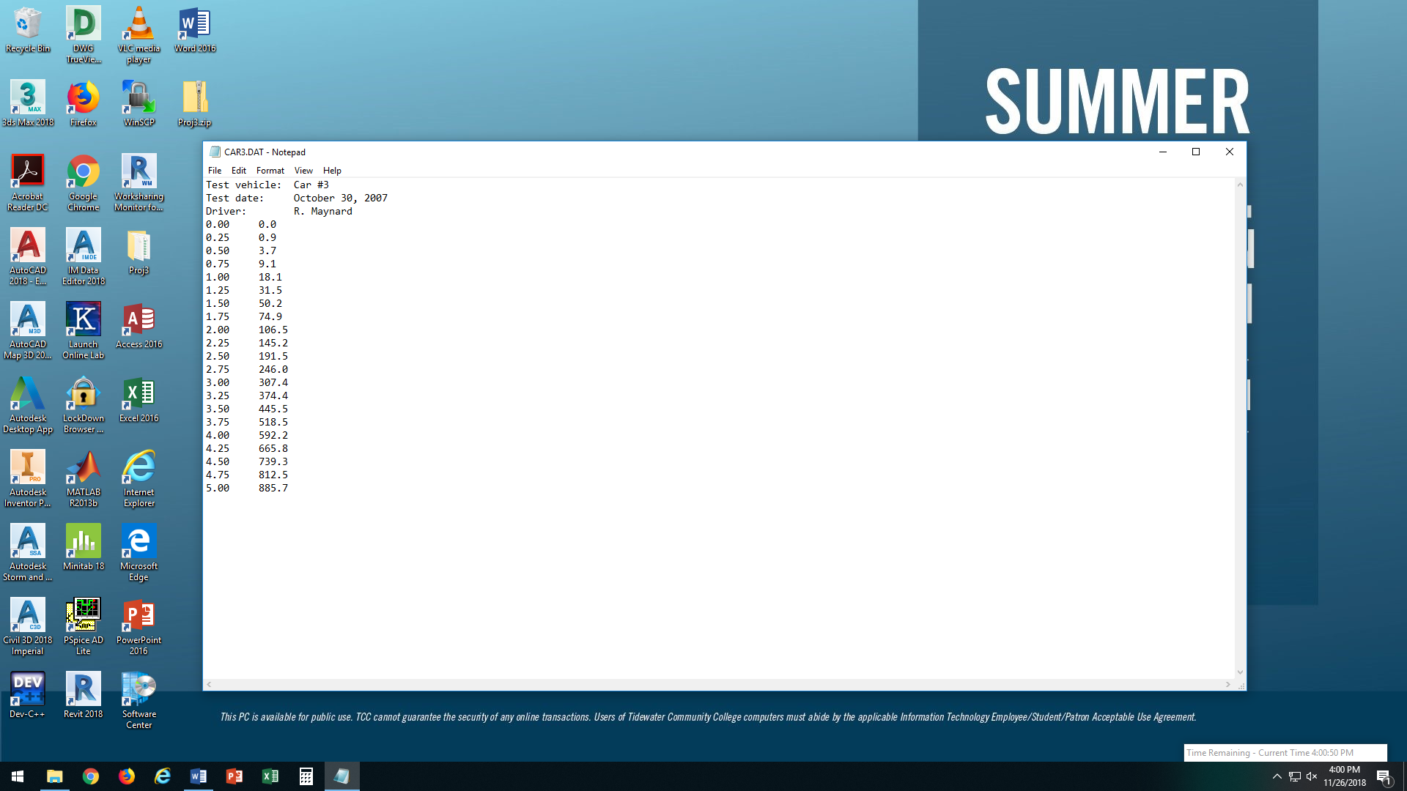 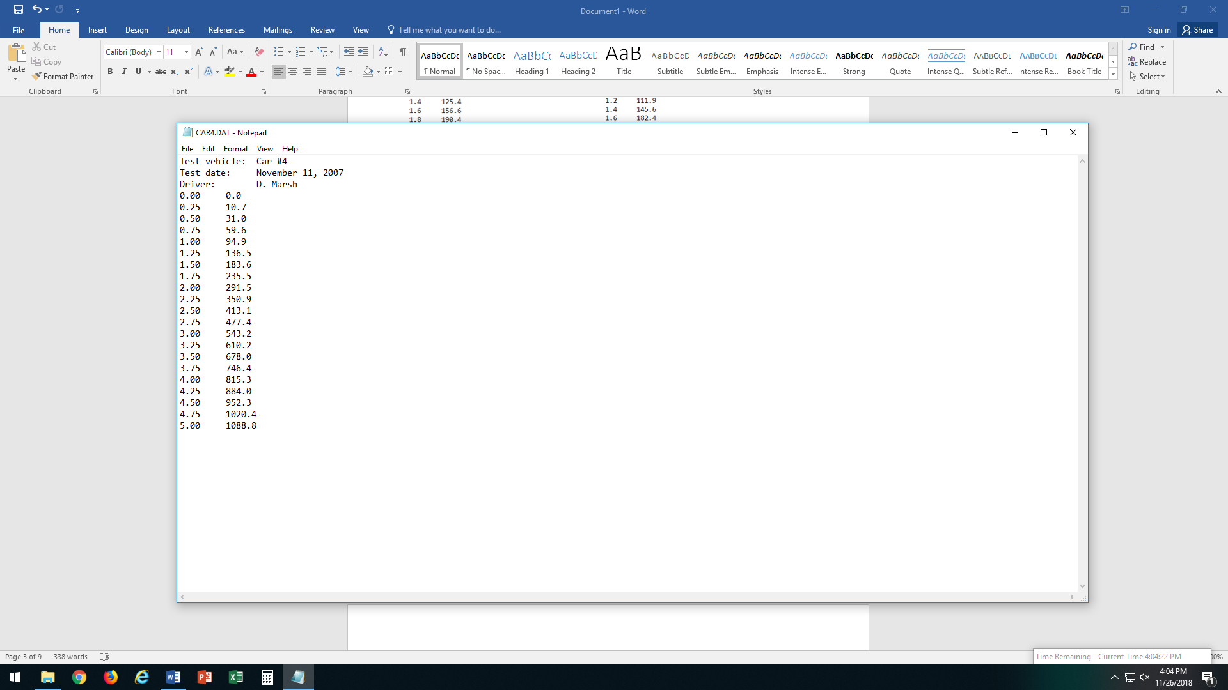

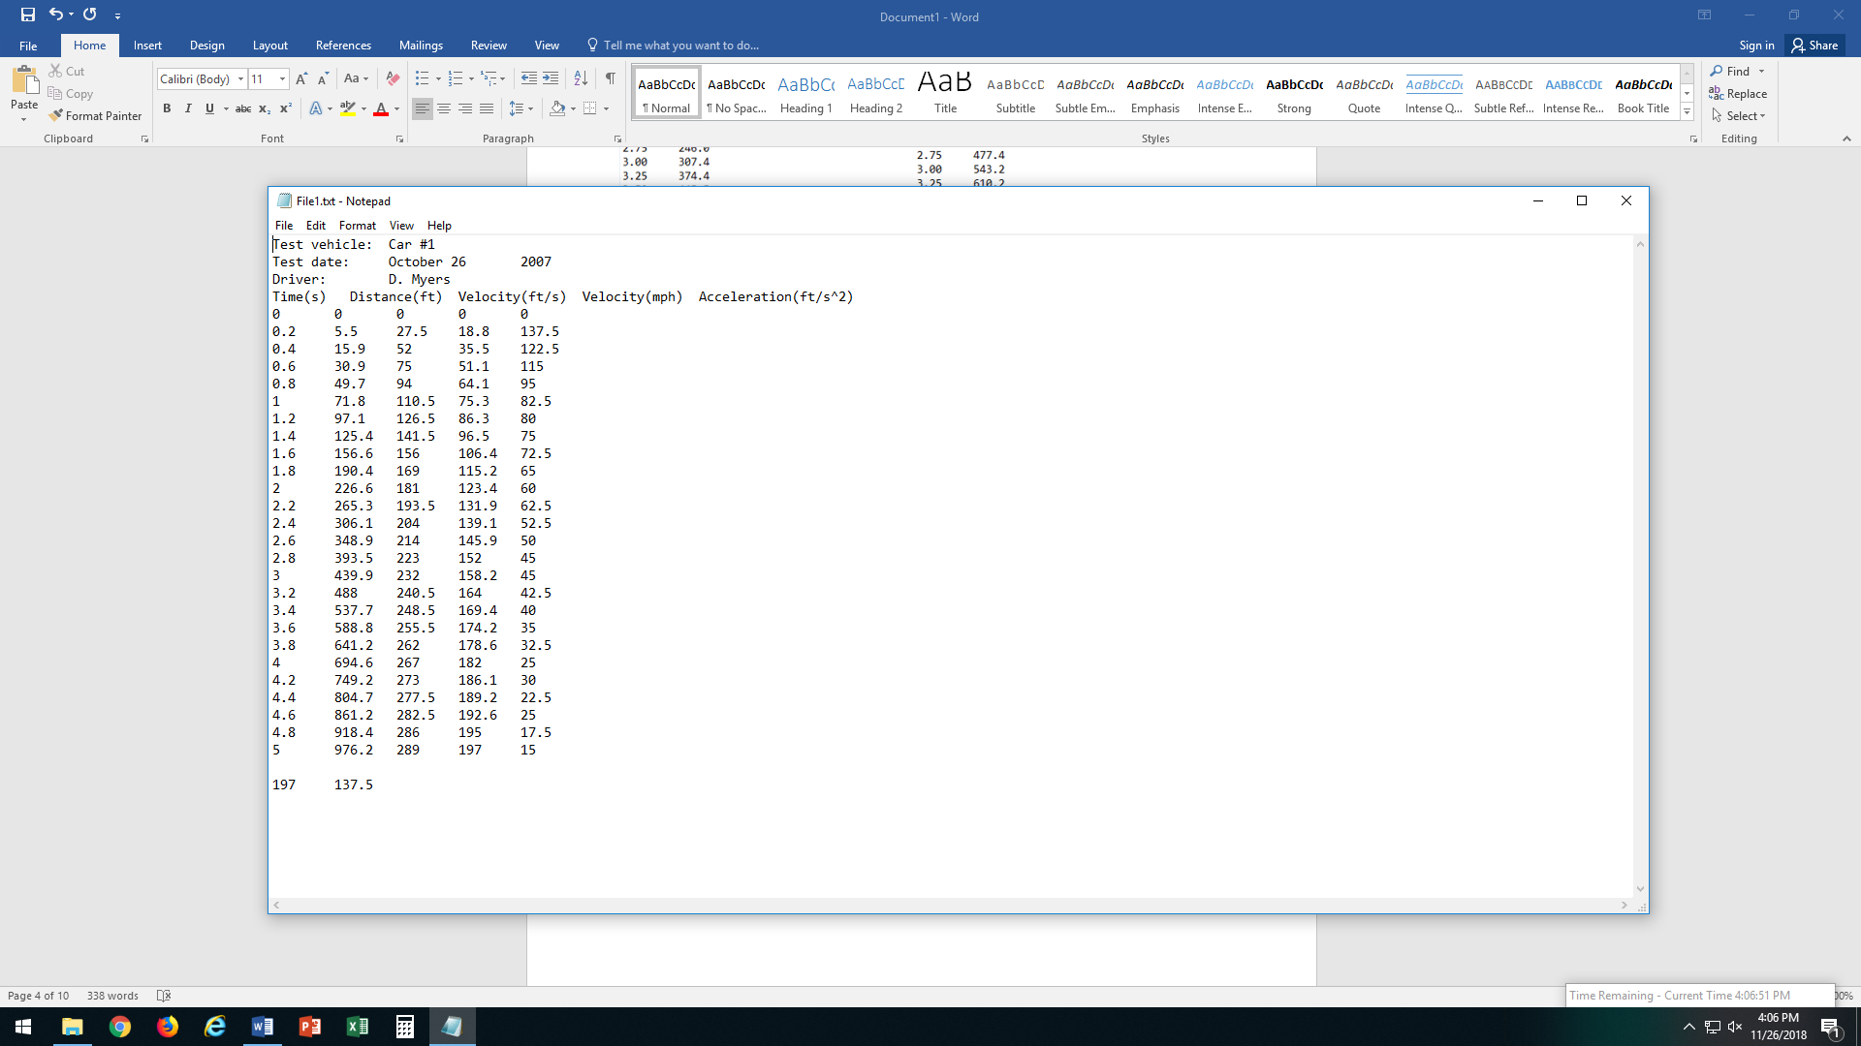 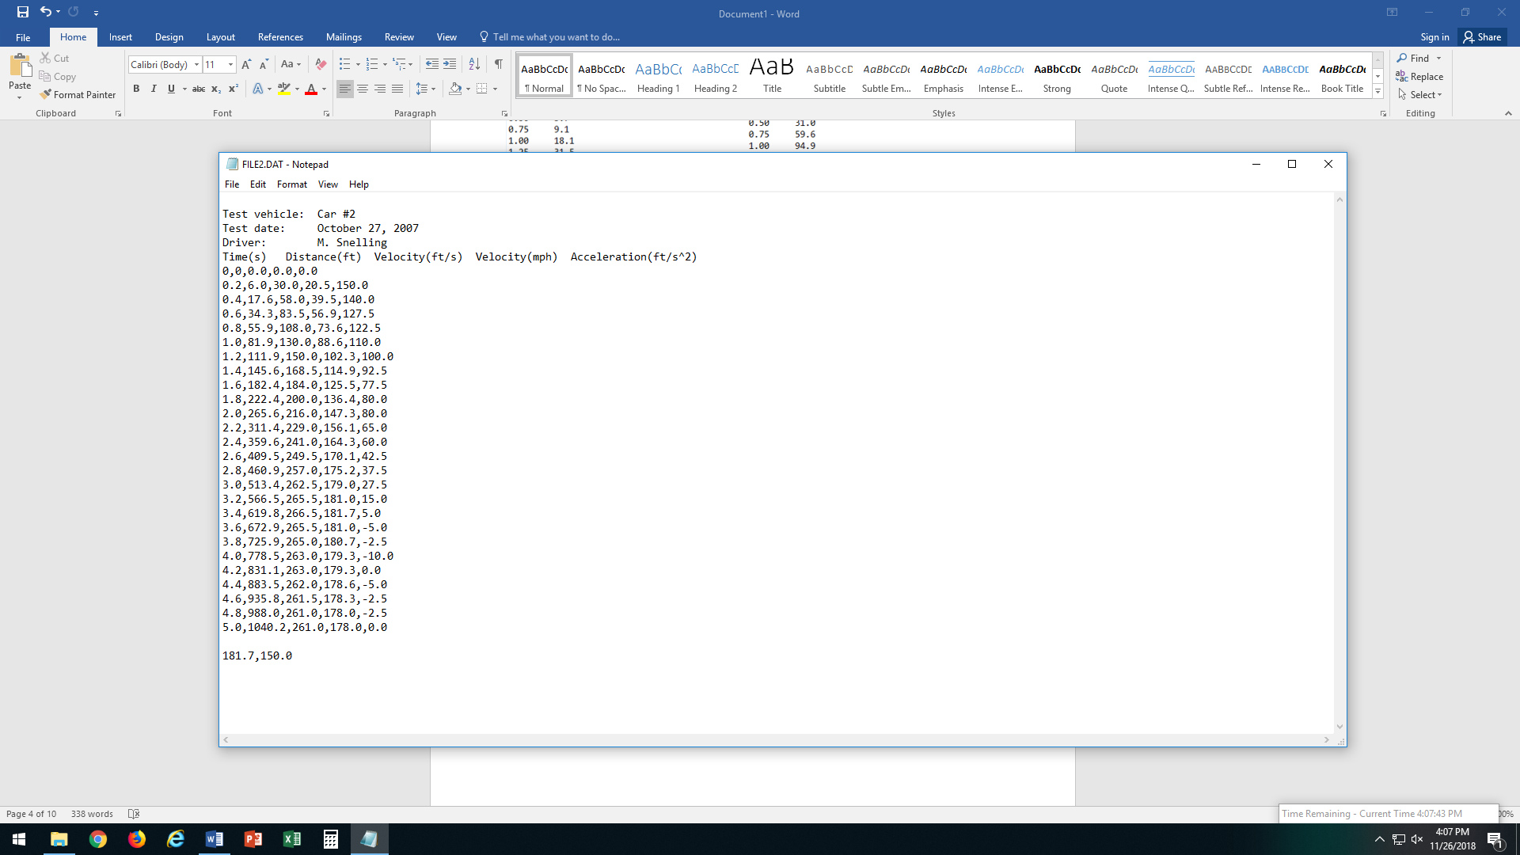

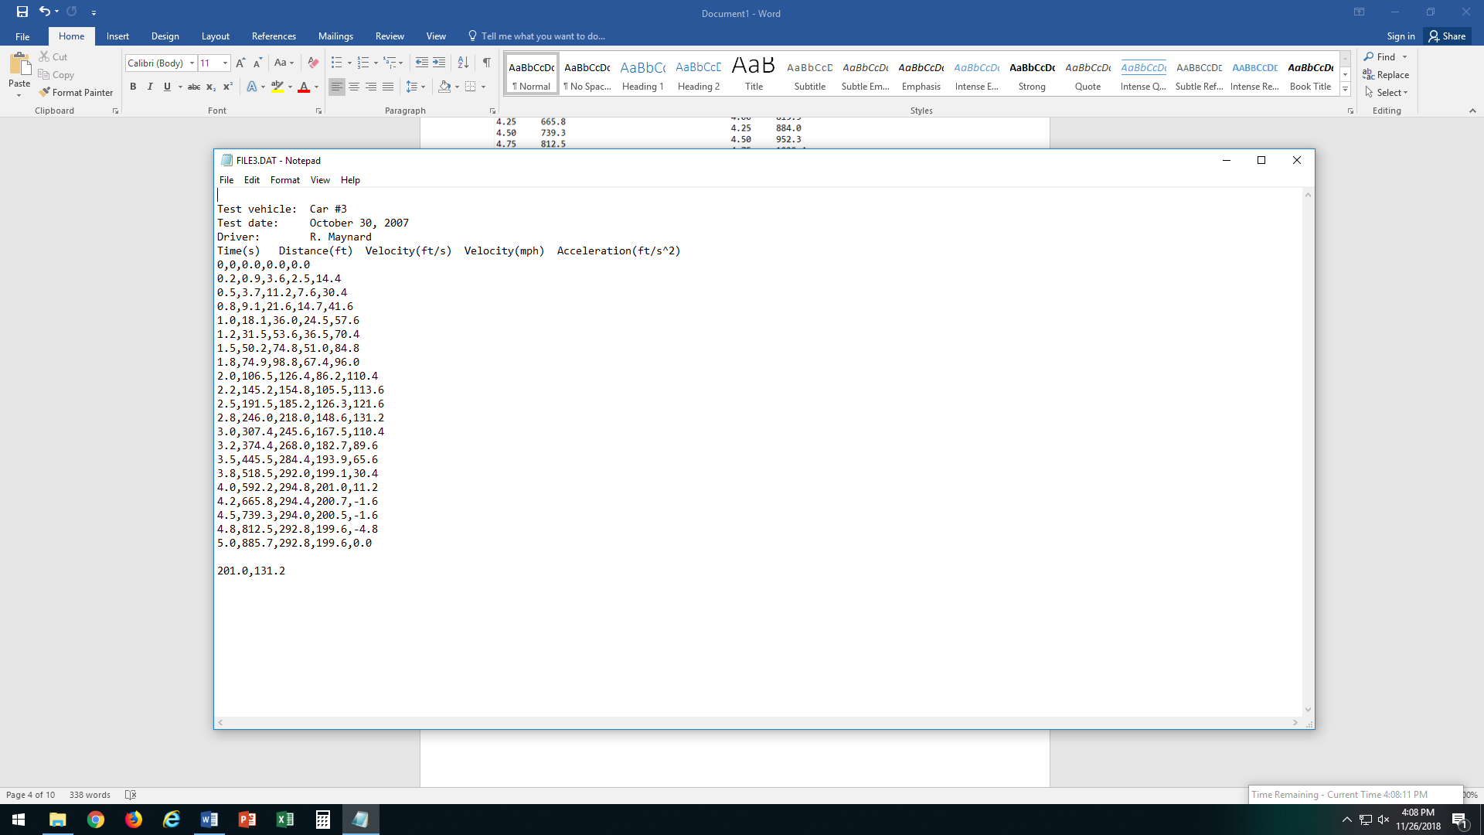

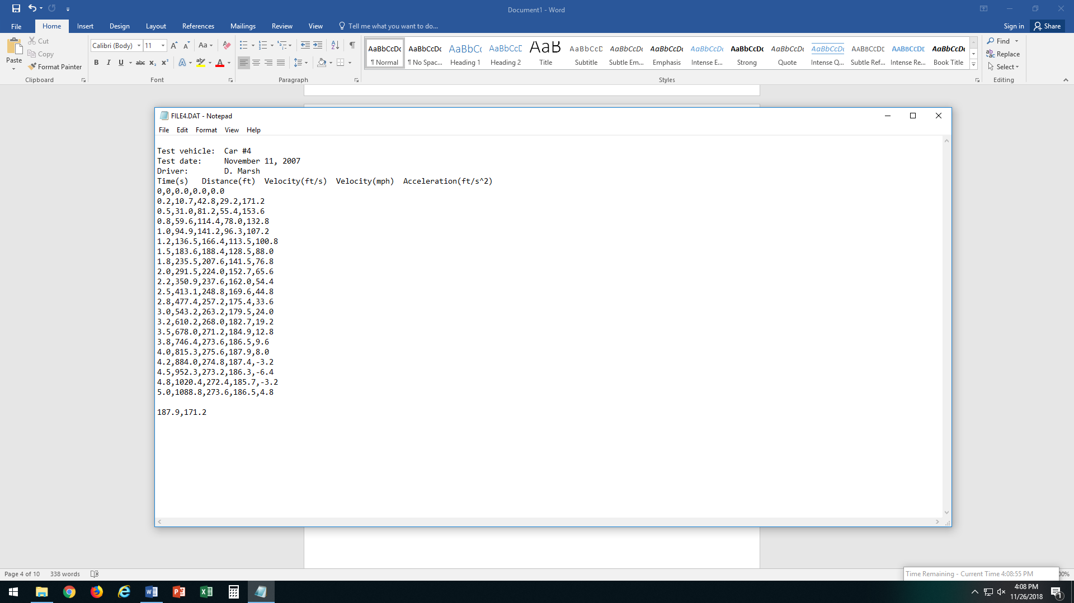

|  |  |  |  |  |  |  |  |  |
| --- | --- | --- | --- | --- | --- | --- | --- | --- |
| |  |  | | --- | --- | | Test vehicle: Car #1 | | | Test date: October 26 | 2007 | | Driver: D. Myers | | | Max velocity=197  Max acceleration = 137.5 | | |

|  |  |  |  |  |
| --- | --- | --- | --- | --- |
| Time(s) | Distance (ft) | Velocity (ft/s) | Velocity (mph) | Acceleration (ft/s^2) |
| 0 | 0 | 0 | 0 | 0 |
| 0.2 | 5.5 | 27.5 | 18.8 | 137.5 |
| 0.4 | 15.9 | 52 | 35.5 | 122.5 |
| 0.6 | 30.9 | 75 | 51.1 | 115 |
| 0.8 | 49.7 | 94 | 64.1 | 95 |
| 1 | 71.8 | 110.5 | 75.3 | 82.5 |
| 1.2 | 97.1 | 126.5 | 86.3 | 80 |
| 1.4 | 125.4 | 141.5 | 96.5 | 75 |
| 1.6 | 156.6 | 156 | 106.4 | 72.5 |
| 1.8 | 190.4 | 169 | 115.2 | 65 |
| 2 | 226.6 | 181 | 123.4 | 60 |
| 2.2 | 265.3 | 193.5 | 131.9 | 62.5 |
| 2.4 | 306.1 | 204 | 139.1 | 52.5 |
| 2.6 | 348.9 | 214 | 145.9 | 50 |
| 2.8 | 393.5 | 223 | 152 | 45 |
| 3 | 439.9 | 232 | 158.2 | 45 |
| 3.2 | 488 | 240.5 | 164 | 42.5 |
| 3.4 | 537.7 | 248.5 | 169.4 | 40 |
| 3.6 | 588.8 | 255.5 | 174.2 | 35 |
| 3.8 | 641.2 | 262 | 178.6 | 32.5 |
| 4 | 694.6 | 267 | 182 | 25 |
| 4.2 | 749.2 | 273 | 186.1 | 30 |
| 4.4 | 804.7 | 277.5 | 189.2 | 22.5 |
| 4.6 | 861.2 | 282.5 | 192.6 | 25 |
| 4.8 | 918.4 | 286 | 195 | 17.5 |
| 5 | 976.2 | 289 | 197 | 15 |

|  |  |  |  |  |  |  |
| --- | --- | --- | --- | --- | --- | --- |
| |  |  | | --- | --- | | Test vehicle: Car #2 | | | Test date: October 27 | 2007 | | Driver: M. Snelling  Max velocity=181.7  Max acceleration=150 | | |

|  |  |  |  |  |
| --- | --- | --- | --- | --- |
| 0 | 0 | 0 | 0 | 0 |
| 0.2 | 6 | 30 | 20.5 | 150 |
| 0.4 | 17.6 | 58 | 39.5 | 140 |
| 0.6 | 34.3 | 83.5 | 56.9 | 127.5 |
| 0.8 | 55.9 | 108 | 73.6 | 122.5 |
| 1 | 81.9 | 130 | 88.6 | 110 |
| 1.2 | 111.9 | 150 | 102.3 | 100 |
| 1.4 | 145.6 | 168.5 | 114.9 | 92.5 |
| 1.6 | 182.4 | 184 | 125.5 | 77.5 |
| 1.8 | 222.4 | 200 | 136.4 | 80 |
| 2 | 265.6 | 216 | 147.3 | 80 |
| 2.2 | 311.4 | 229 | 156.1 | 65 |
| 2.4 | 359.6 | 241 | 164.3 | 60 |
| 2.6 | 409.5 | 249.5 | 170.1 | 42.5 |
| 2.8 | 460.9 | 257 | 175.2 | 37.5 |
| 3 | 513.4 | 262.5 | 179 | 27.5 |
| 3.2 | 566.5 | 265.5 | 181 | 15 |
| 3.4 | 619.8 | 266.5 | 181.7 | 5 |
| 3.6 | 672.9 | 265.5 | 181 | -5 |
| 3.8 | 725.9 | 265 | 180.7 | -2.5 |
| 4 | 778.5 | 263 | 179.3 | -10 |
| 4.2 | 831.1 | 263 | 179.3 | 0 |
| 4.4 | 883.5 | 262 | 178.6 | -5 |
| 4.6 | 935.8 | 261.5 | 178.3 | -2.5 |
| 4.8 | 988 | 261 | 178 | -2.5 |
| 5 | 1040.2 | 261 | 178 | 0 |

***Discussion***

**Performance:**

This program reads data from a file and calculates velocity, acceleration, and the maximum velocity and acceleration.

**Potential Improvements:**

* Average velocity and acceleration
* Option to reenter file name if chosen name isn’t valid